CALCULUS

WORKSHEET ON DERIVATIVES

Work the following on notebook paper except for problem 12. Do not use your calculator.

On problems 1 – 4, find the critical points of each function, and determine whether they are relative maximums or relative minimums by using the Second Derivative Test whenever possible.

1.  2. 

3.  4. 

________________________________________________________________________________

5. Suppose that the function *f* has a continuous second derivative for all *x* and that

. Let *g* be a function whose derivative is given

by  for all *x*.

(a) Write an equation of the line tangent to the graph of *f*  at the point where .

(b) Does *g* have a local maximum or a local minimum at ? Justify your answer.

________________________________________________________________________________

6. Conside the curve given by 

(a) Show that 

(b) Show that there is a point *P* with *x*-coordinate 3 at which the line tangent to the curve at *P*

is horizontal. Find the *y*-coordinate of *P*.

(c) Find the value of  at the point *P* found in part (b). Does the curve have a local

maximum, a local minimum, or neither at point *P*? Justify your answer.

________________________________________________________________________________

On problems 7 – 8, the graph of the derivative, , of a function *f* is shown.

(a) On what interval(s) is *f* increasing or decreasing? Justify your answer.

(b) At what value(s) of *x* does *f* have a local maximum or local minimum? Justify your

answer.

7. 8. 





________________________________________________________________________________

9. The graph of the second derivative, , of a function *f* is shown. State the *x*-coordinates

of the inflection points of *f*. Justify your answer.





**TURN->>>**

10. The function *h* is defined by , where *f* and *g* are the functions whose

graphs are shown below.

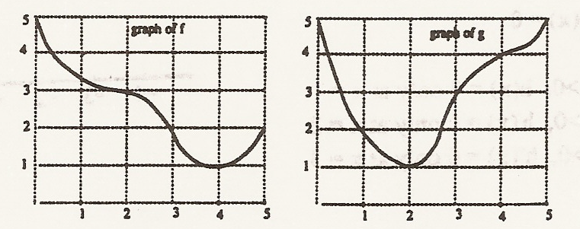

(a) Evaluate .

(b) Estimate .

(c) Is the graph of the composite function *h* increasing or decreasing at *x* = 3? Show your

reasoning.

(d) Find all values of *x* for which the graph of *h* has a horizontal tangent. Show your reasoning.

________________________________________________________________________________

11. For what values of *a* and *b* does the function  have a local

maximum when  and a local minimum when ?

________________________________________________________________________________

12. Sketch the graph of a function  that meets all of the following criteria:

 1) The domain of *f*  is .

2) 

3) For *x* > 0, = 0 only at *x* = 1.

4) For *x* > 0, = 0 only at *x* = 2.

5) For *x* > 0, = 0 only at *x* = 3.

6) 

7) 

Answers to Worksheet on Second Derivative Test

1. Rel. max. at (0, 3), rel. min. at (2, - 1)

2. Rel. max. at , rel. min. at (2, 4)

3. Rel. max. at , rel. min. at 

4. Rel. min. at , rel. max. at 

5. (a) 

(b) Local minimum at  because .



7. (a) incr. on ; decr. on (0, 3) (b) Rel. max. at *x* = 0, rel. min. at *x* = 3

8. (a) decr. on ; incr. on 

(b) Rel. min. at *x* = 1, *x* = 5; rel. max. at *x* = 3

9. *x* = 1 and *x* = 7

10. (a) 3.4 (b)  (c) decr. (d) 2, 0.25, 4

11. *a* = 6, *b* = 9

12.