Name_____________________________________ Section_________________

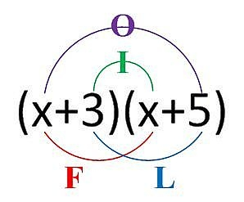

**ONLINE HOMEWORK**

**Multiplying Binomials**

**FOIL or Box Method Practice Worksheet**

**Find Each Product Do FOIL Method for the Odds, Box for Evens**

**1.** (x + 1)(x + 1)

FOIL: x² + x + x + 1 = x² + 2x + 1

BOX:

|  |  |  |
| --- | --- | --- |
|  | x | +1 |
| x | x² | x |
| +1 | x | 1 |

= x² + 2x + 1

**2.** (x + 1)(x + 2) **3.** (x + 2)(x + 3)

**4.** (x + 3)(x + 2) **5.** (x + 4)(x + 3)

**6.** (x - 6)(x + 2) **7.** (x - 5)(x - 4)

**8.** (y + 6)(y + 5) **9.** (2x + 1)(x + 2)

**10.** (y + 6)(3y + 2) **11.** (2x + 1)(2x + 5)

**Multiplying Binomials Cont…**

**12.** (x + 5)(3x - 1) **13.** (2x - 1)(x - 3)

**14.** (x + y)(x + y) **15.** (3x + y)(x + y)

**16.** (2x + y)(2x – y) **17.** (3x - y)(x + 2y)

**Find the area of each shape.**

**18.** **19.**

x + 3 x + 6

x + 3

x + 3

**20.** **21.**

2x + 7

x - 2 x + 2

4x - 2