Finding Limits Through Tables and Graphs

Classwork Day 13.

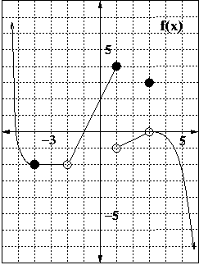

**1.** Evaluate    

**2.** Finding limits using a table**.** Find.

|  |  |  |  |  |  |  |  |
| --- | --- | --- | --- | --- | --- | --- | --- |
| *x* | 1.99 | 1.999 | 1.9999 | 2 | 2.0001 | 2.001 | 2.01 |
|  |  |  |  | ? |  |  |  |

**3.** Fill in the given table and use it to find.

|  |  |  |  |  |  |  |  |
| --- | --- | --- | --- | --- | --- | --- | --- |
| *x* | -0.01 | -0.001 | -0.0001 | 0 | 0.0001 | 0.001 | 0.01 |
|  |  |  |  | ? |  |  |  |

4. Generate a table of values to find each of these limits. Include the table.

A. 

B. 

C. 

D. 

E. 

F.

G. 

H.