Algebra II UNIT 1 Review
1. An irrational number is a number that never ends and never repeats. Circle the numbers that are irrational (there are two of them)
15 $\sqrt{16}$ $\sqrt{7}$ 4.080080008….. 9/4
2. If 9(x + 6) = 36, then x + 2 equals _________________

3. In the equation 4|x – 24|-90 = 75, how would you ISOLATE the absolute value expression?

4. What’s the difference between x = 8 and x < 8?

5. $8+2∙3^{2}÷6-14$  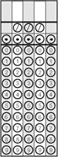 | 6. ${(n-d)}^{2}+3d^{2}$ if n = 5 and d = - 2
7. | x-7| when x = -5  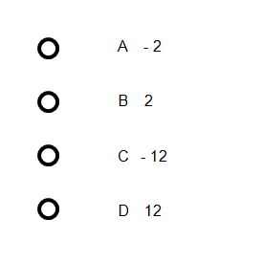 | 8. 2 |x| - 4| 2 + y| when x = - 4 and y = - 3  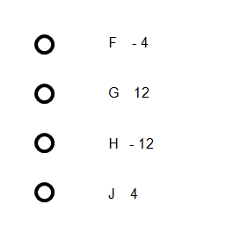

9. Simplify: $1/{2 }$(16x – 6y) – 2(x + 12y) 9. ________

Solve the following equations:
10. $-6\left(n-8\right)= 4(12-5n)$ 10 ________

11. $2\left|3x-5\right|=14$ 11 ________

12. $\left|y-8\right|+7=3$ 12 ________

13. $10t-14<12t+6$ 13 ________

14. $-3≤w+9≤12$ 14 ________

15. $\left|x-3\right|>5$ 15 ________

16. $\left|3w-7\right|≤2$ 16 ________

17. Solve $\left|-8x+7\right|=-15$

18. (BCR) Ms. Samuels is renting a car for two days. She has budgeted between $100 and $120 for this expense. If the rental agency charges $30.00 per day and $.40 per mile, write an inequality to represent the range of mileage (m) that will keep Ms. Samuels within her budget.

Solve for the maximum number of miles that she can drive and still stay within her budget.

